DEPARTMENT OF COMPUTER & INFORMATION SYSTEMS ENGINEERING BACHELORS IN COMPUTER SYSTEMS ENGINEERING
Course Code: CS-324
Course Title: Machine Learning
Complex Engineering Problem
TE Batch 2023, Spring Semester 2026
Grading Rubric 1: Dataset Collection and Preprocessing (Milestone 2)
TERM PROJECT
Group Members:

Student No. | Name | Roll No.
S1 | Mashaal Ali | CS-23091
S2 | Anas Yazdani | CS-23102
S3 | Osama Humayun | CS-23139
S4

CRITERIA AND SCALES |  |  |  | Marks Obtained
 |  |  |  | S1 | S2 | S3 | S4
Criterion 1: Data collection, labeling, and dataset quality.
(CPA-1, CPA-3) [4 marks]
1 | 2 | 3 | 4
Data collection or  labeling is incomplete, incorrect, or poorly  justified. | Data collection and  labeling are partially  completed with quality issues. | Data collection and  labeling are complete and mostly correct. | Data collection and  labeling are complete, accurate, and well  justified, resulting in a high-quality dataset.
Criterion 2: Preprocessing pipeline and exploratory data analysis (EDA).
(CPA-1, CPA-2) [4 marks]
1 | 2 | 3 | 4
Preprocessing and EDA are missing or  incorrectly applied. | Preprocessing or EDA is applied partially or  superficially. | Preprocessing and EDA are applied correctly with minor gaps. | Preprocessing and EDA are comprehensive,  correct, and well documented.
Criterion 3: Report quality and adherence to format.
[2 marks]
1 | 2 | 3 | 4
The report is poorly  written and does not  follow the given format. | The report partially follows the format and lacks  clarity. | The report follows the format with minor  formatting or clarity issues. | The report is clear, well written, and fully adheres to the given format and  requirements.
Final Score = (Criteria_ 1_score ) + (Criteria_2_score) + (Criteria_3_score) = ______________

Teacher’s Signature

Description of Data Collection Methods and Sources

Data Source:
The dataset used in this project is entirely self-collected. All images were captured using smartphone cameras, ensuring that the data reflects real-world conditions rather than ideal or artificially generated scenarios. The focus of the dataset is on Pakistani currency notes of different denominations, with both the front and back sides included for each note.

Data Collection Process:
Images were captured manually by placing currency notes in different environments and taking photographs from multiple perspectives. To ensure variability and improve model robustness, the images were taken under diverse conditions, including:
- Different lighting conditions (natural light, indoor light, shadows)
- Varying angles and orientations
- Different distances from the camera
- Multiple backgrounds (plain and complex)
This variation is important because it helps the model generalize better and perform accurately when exposed to unseen real-world inputs.

Data Selection and Filtering:
After collecting a large number of images, a manual filtering process was carried out to ensure data quality. During this step:
- Blurry images were removed
- Overexposed and underexposed images were discarded
- Images with partially visible or obstructed notes were excluded
- Only clear, unique, and properly captured images were selected
This step was necessary to maintain a high-quality dataset and reduce noise that could negatively impact model performance.

Dataset Organization and Labeling:
The cleaned dataset was organized using a folder-based structure, where each folder represents a distinct class. Each class corresponds to a specific currency denomination and its side (front or back).
Example folder structure:
- 10_front
- 10_back
- 50_front
- 50_back
This organization allows automatic labeling during model training, as most deep learning frameworks assign labels based on folder names. This approach simplifies the labeling process and reduces the chances of human error.

Dataset Statistics

Overview:
Following the data collection and preprocessing stages, the final dataset consists of images of Pakistani currency notes across multiple denominations. Each denomination is represented by two classes corresponding to the front and back sides of the note.
To ensure consistency and reliability, the dataset was cleaned, standardized, and balanced as much as possible. The final dataset is structured to support supervised image classification tasks, where each class represents a unique denomination-side combination.

Class-wise Distribution:
Class Label | Description | Number of Images
10_front | Front side of 10 PKR note | 105
20_front | Front side of 20 PKR note | 106
50_front | Front side of 50 PKR note | 110
100_front | Front side of 100 PKR note | 107
500_front | Front side of 500 PKR note | 103
1000_front | Front side of 1000 PKR note | 102
5000_front | Front side of 5000 PKR note | 101

Denomination-wise Distribution:
This table groups the data by currency value (combining front and back images):
Denomination (PKR) | Total Images
10 | 207
20 | 210
50 | 218
100 | 211
500 | 204
1000 | 202
5000 | 201

Dataset Summary Statistics:
Metric | Value
Total Number of Classes | 14
Total Images | 1453
Average Images per Class | ~104
Minimum Images in a Class | 100
Maximum Images in a Class | 110
Number of Denominations | 7
Image Format | JPG
Image Dimensions | 224 × 224 pixels

Train–Validation–Test Split:
The dataset was divided into training, validation, and testing subsets using a 70–15–15 ratio.
Dataset Split | Percentage | Approx. Number of Images
Training Set | 70% | ~1017
Validation Set | 15% | ~218
Test Set | 15% | ~218

Analysis:
The dataset demonstrates a well-balanced distribution across all classes, with only minor variations in the number of images per category. This balance is important to ensure that the model does not become biased toward any specific denomination or side during training.
Additionally, grouping the data by denomination shows that each currency value is fairly equally represented, which helps the model learn distinguishing features across different note types effectively.
The dataset has also been standardized in terms of image size (224 × 224 pixels) and format (JPG), which ensures uniformity and reduces computational complexity during model training.
Finally, the use of a 70–15–15 split ensures that sufficient data is available for training while preserving separate sets for validation and unbiased performance evaluation.

Detailed Pre-processing Steps

Overview:
Before training the machine learning model, the collected data-set underwent several pre-processing steps to ensure data quality, consistency, and suitability for deep learning. Raw image data collected from real-world environments often contains inconsistencies such as varying formats, different image sizes, duplicates, and noise.
To address these issues, a structured pre-processing pipeline was implemented. The main steps included labeling, cleaning, normalization, encoding, and data augmentation. Each of these steps plays a crucial role in improving model performance, stability, and generalization.
The pre-processing process was carried out using Python-based tools and libraries, ensuring reprehensibility and efficiency.

1. Labeling

Method Used:
A folder-based labeling approach was used to assign class labels to the images. In this method, each class is represented by a separate folder, and the name of the folder serves as the label for all images contained within it. The folders were manually created with classes assigned to each folder.
Each class corresponds to a specific combination of currency denomination and note side (front or back). For example:
10_front → Front side of 10 PKR note
1000_front → Front side of 1000 PKR note
This structure was maintained consistently across the entire dataset.

Why This Approach Was Used
This method was chosen because it is simple, scalable, and directly compatible with deep learning frameworks such as TensorFlow and Keras. These frameworks automatically read folder names and assign numeric labels to each class during data loading, eliminating the need for manual annotation files.
It also reduces the chances of labeling errors and ensures a clean mapping between images and their respective classes.

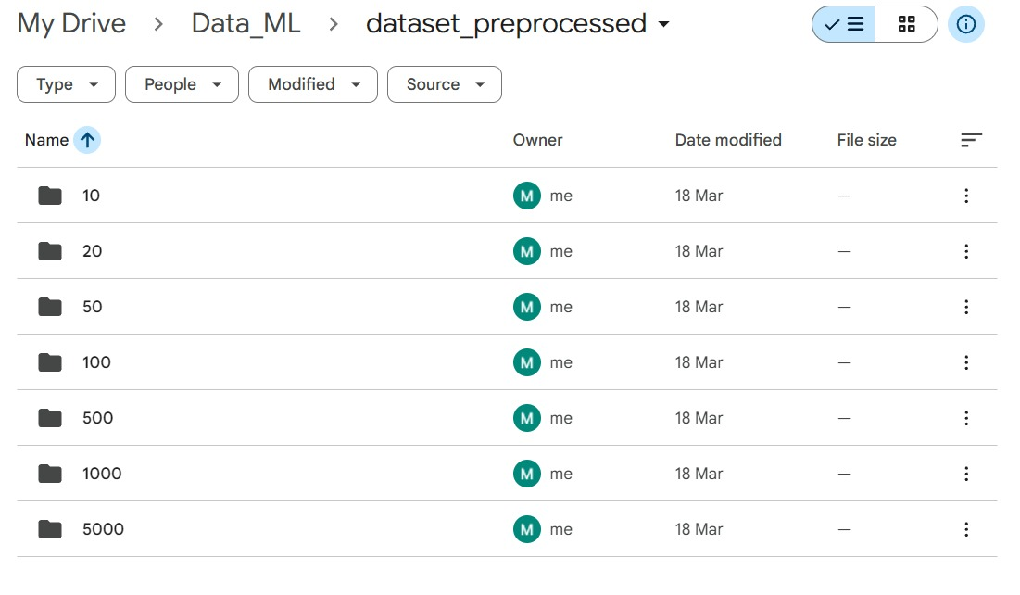
As a result of this labeling strategy:
- Each image was correctly mapped to its corresponding class
- The dataset remained organized and easy to manage
- The labeling process was automated and error-free
- The data became directly usable for supervised learning tasks

2. Data Cleaning

Objective:
The purpose of the data cleaning step was to improve the overall quality of the dataset by removing noise, inconsistencies, and redundant data. Since the images were collected manually using mobile devices, the raw dataset contained several issues such as duplicate images, unsupported formats, and corrupted files. These issues can negatively affect model performance if not handled properly.

Duplicate Image Removal:
After format conversion, duplicate images were identified and removed. Duplicates were introduced due to repeated captures and also because converted images existed alongside their original versions.
To address this, an image hashing technique was used to detect visually identical or near-identical images. If two images produced the same hash value, one of them was removed.

Code Snippet:
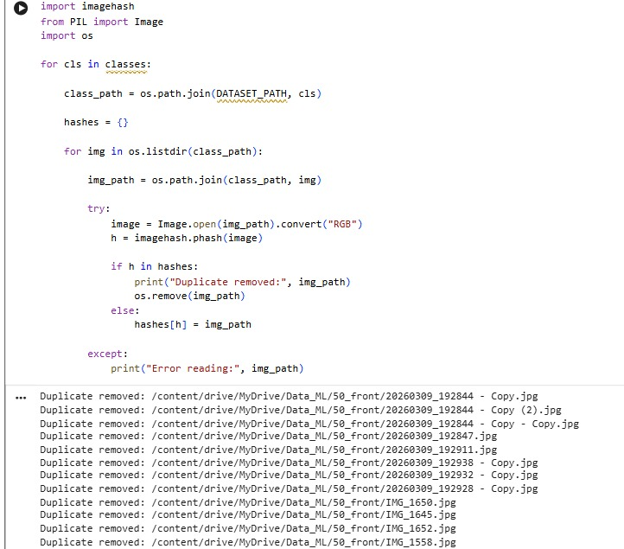

Manual Cleaning:
The first stage of cleaning was performed manually. After collecting the images, a visual inspection was carried out to filter out low-quality data. During this step:
- Blurry images were removed
- Images with poor lighting (too dark or overexposed) were discarded
- Partially captured or cut-off currency notes were excluded
- Only clear, properly framed, and unique images were retained
This ensured that the dataset only contained high-quality samples suitable for training.

Corrupted Image Removal:
Some images in the dataset were unreadable or partially damaged, which caused errors during processing (e.g., “cannot identify image file” or “image file is truncated”).
To handle this, all images were checked programmatically. Any file that could not be opened successfully was considered corrupted and removed.
Additionally, truncated images were allowed to load during preprocessing to avoid unnecessary crashes.

Code Snippet:
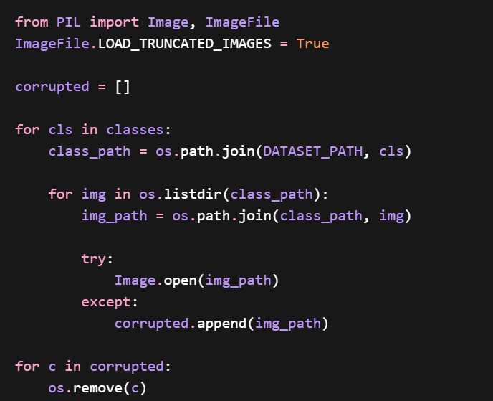

Outcome:
After completing the cleaning process:
- Duplicate images were successfully removed
- Corrupted and unreadable files were eliminated
- Only high-quality, unique images remained in the dataset
This significantly improved the reliability and quality of the dataset, ensuring that the model would train on clean and meaningful data.

3. Normalization

Objective:
The normalization step was performed to standardize the dataset so that all images have consistent dimensions, format, and pixel value ranges. Since the images were captured using different devices and under varying conditions, they originally had different sizes, resolutions, and intensity distributions.
Without normalization, these inconsistencies can negatively impact model training, slow down convergence, and reduce overall performance.

Format Standardization (HEIC to JPG Conversion):
The dataset initially contained images in multiple formats, including HEIC, JPG, and JPEG. Since HEIC format is not consistently supported by many deep learning libraries, all HEIC images were converted into JPG format.
During this process:
- HEIC images were converted to RGB format
- Converted images were saved as .jpg files
- Original HEIC files were removed after conversion to avoid duplication

Code Snippet:
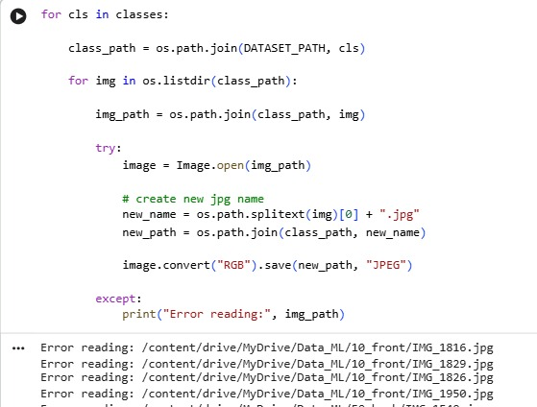

Image Resizing (Spatial Normalization):
After the cleaning process, images still had varying dimensions depending on how they were captured. To ensure compatibility with convolutional neural networks (CNNs), all images were resized to a fixed resolution of 224 × 224 pixels.
This size was selected because it is a commonly used input dimension for many deep learning architectures and provides a good balance between computational efficiency and feature preservation.
Resizing ensures that:
- All images have uniform dimensions
- Batch processing becomes efficient
- The model can learn spatial features consistently

Code Snippet:
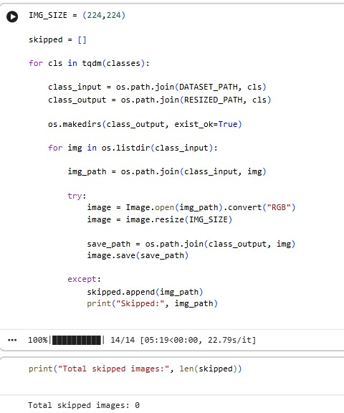

Color Format Standardization:
All images were converted into RGB format to ensure consistency across the dataset. This step was necessary because some images (especially after format conversion) may have different channel configurations.
By enforcing RGB format:
- Each image contains exactly 3 color channels
- Input data remains consistent for the model
- Compatibility with deep learning frameworks is ensured

Code Snippet:


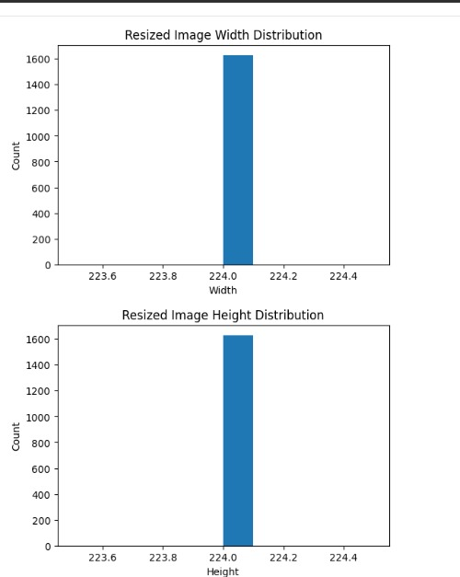
Outcome:
After normalization:
- All images were converted into a consistent format (JPG)
- All images were resized to a uniform resolution of 224 × 224 pixels
- Image channels were standardized to RGB format
This ensured that the dataset was fully standardized and optimized for deep learning, allowing the model to train more efficiently and learn meaningful patterns without being affected by inconsistencies in the raw data.

4.Encoding

Objective:
Encoding is the process of converting categorical class labels into a numerical format that can be understood by machine learning models. Since neural networks cannot process textual labels directly, each class label must be transformed into a numeric representation before training.

Label Encoding Approach:
In this project, class labels were encoded automatically during dataset loading using a directory-based data generator. Each folder name, representing a specific currency denomination and note side, was mapped to a unique numeric index.
For example:
- "10_front" → Class Index 0
- "10_back" → Class Index 1
- "50_front" → Class Index 2
This mapping was handled internally by the data generator, ensuring consistency and eliminating the need for manual label encoding.

One-Hot Encoding:
After assigning numeric indices, the labels were further converted into one-hot encoded vectors using the categorical class mode.
One-hot encoding represents each class as a binary vector, where:
Only one element is set to 1 (indicating the correct class)
All other elements are set to 0
This encoding scheme is particularly suitable for multi-class classification problems, as it allows the model to output class probabilities and learn distinctions between multiple categories effectively.

Example of Encoding:
Class "10_front" → Index 1 → One-Hot Vector:
[0 1 0 0 0 …]
Class "50_back" → Index 2 → One-Hot Vector:
[0 0 1 0 0 …]
This encoding was implemented using:
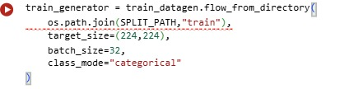

Outcome:
As a result of this encoding process:
- All class labels were converted into numerical format automatically
- One-hot encoding enabled the model to handle multi-class classification effectively

5. Data Augmentation

Objective:
Data augmentation was applied to artificially increase the diversity of the training dataset. Since the dataset was manually collected and relatively limited in size, augmentation helps the model generalize better by exposing it to slightly varied versions of the same images.
This is particularly important for real-world applications, where images may differ in orientation, lighting, and positioning.

Augmentation Strategy Used:
In this project, augmentation was applied only to the training dataset, while the validation and test datasets were kept unchanged (except for rescaling). This ensures that model evaluation remains fair and unbiased.
The following augmentation techniques were used:
- Rotation (up to ±15 degrees)
Helps the model handle slight tilts in captured images
- Horizontal Flipping
Introduces mirrored versions of images
- Brightness Adjustment (range 0.8 – 1.2)
Simulates different lighting conditions
- Zoom (up to 10%)
Allows the model to focus on slightly scaled variations
- Width and Height Shifting (up to 5%)
Simulates small positional changes in the image

Implementation in Code:
The augmentation was implemented using an image data generator:
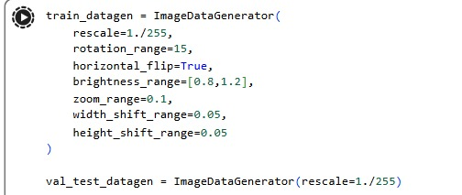

How Augmentation Works in This Project:
In this implementation, augmentation is performed dynamically during training using the data generator.
- No augmented images are stored on disk
- Images are transformed in memory (on-the-fly)
- Each time an image is loaded, a slightly modified version is generated
This means that:
- The model sees a different variation of the same image in different training iterations
- The effective dataset size increases without physically duplicating data

Number of Generated Images:
In this approach, there is no fixed number of augmented images per original image.
Instead:
Each image can produce multiple different variations across epochs
The total number of augmented samples depends on:
- Batch size
- Number of training steps
- Number of epochs
This makes the augmentation process flexible and more efficient compared to static augmentation.

Outcome:
As a result of applying data augmentation:
- The model is exposed to more diverse training samples
- Overfitting is reduced
- Generalization to real-world scenarios is improved
Since augmentation was applied only to the training set and not to validation or testing sets, the evaluation results remain reliable and unbiased.

